**Hackathon Project Phases Template** for the **Autosage App** project.

# **Hackathon Project Phases Template**

## **Project Title:**

**StudBud : AI Study Planner**

## **Team Name:**

MindSpark

## **Team Members:**

* Poloju Sriusha
* Sriramula Geetha
* Jangiti Srivani
* Pabbathi Upender

## **Phase-1: Brainstorming & Ideation**

### **Objective:**

Develop an **AI Study Planner** expert tool using Gemini Flash to help users compare and analyze study specifications, reviews, understanding and options.

### **Key Points:**

1. **Problem Statement:**

*Students struggle with inefficient study habits due to overwhelming workloads and lack of personalized planning tools.

*Generic study plans fail to meet individual student needs, hindering effective learning and academic succes

2 **Proposed Solution:**

*AI Study Planner provides personalized, adaptive study schedules that optimize

learning and boost academic performance

*AI Study Planner uses data-driven insights to create tailored study plans, helping

students learn smarter, not harder

**3 Target Users:**

*Students of all levels seeking a more organized and effective way to study.

*Overwhelmed students looking for a personalized and adaptive study solution.

*Busy students wanting to study smarter.

**4 Expected Outcome:**

*Students achieve better grades and academic performance

*Smarter studying, better results.

## **Phase-2: Requirement Analysis**

### **Objective:**

Define the technical and functional requirements for the AI Study Planner

### **Key Points:**

1. **Technical Requirements:**
   * Programming Language: **Python**
   * Backend: Python (for AI).
   * Frontend: JavaScript (for web/phone).
   * AI Tools: scikit-learn,TensorFlow/PyTorch
   * Database: Standard SQL Database.
   * Structure :Web interface talks to API with AI server in python.
2. **Functional Requirements:**

User Accounts: Create/login to profile.

Smart Planner: Creates daily schedule with suggestions.

AI Helper: Provides study advice, and timed-quizes/content from study tracking.

Basic Actions:Input class/study times/busy time, deadlines.

1. **Constraints & Challenges:**Building takes time with limitations and initial hurdles around AI data.

Handling student private data with good security standards.

## **Phase-3: Project Design**

### **Objective:**

Develop the architecture and user flow of the application.

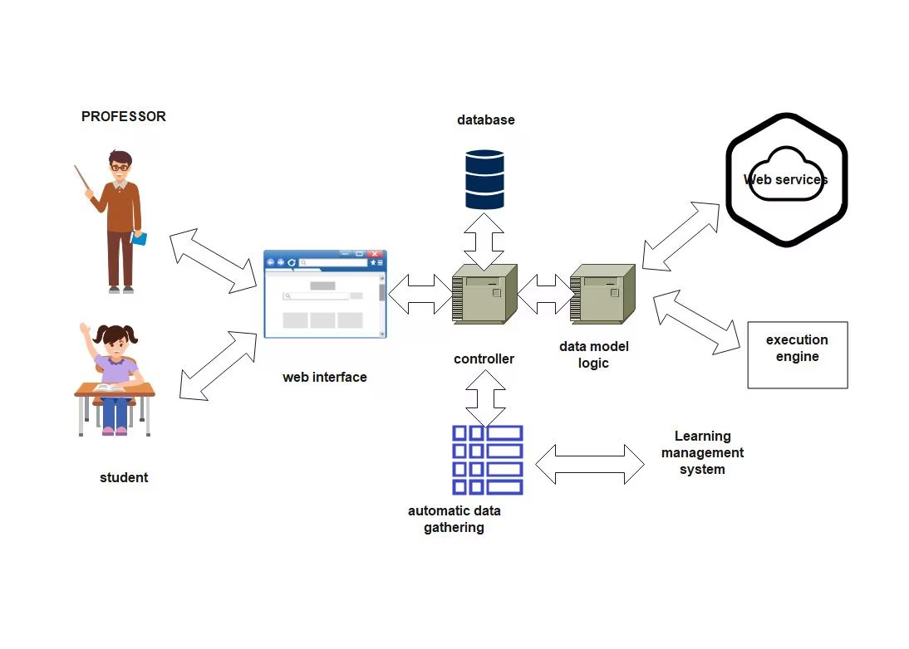

### **Key Points:**

1. **System Architecture:**
   * User interacts with the frontend.
   * Frontend sends data requests to the backend **Gemini API**.
   * AI Engine processes data and sends results back to the backend
2. **User Flow:**
   * Step 1: start : sign up/log in
   * Step 2: input: Add courses &tasks .
   * Step 3: Schedule:Get a study plan
   * Step 4:Track mointor progress
3. **UI/UX Considerations:**
   * **Clarity & Simplicity**
   * **Goal: Tailored experience for each user.**
   * **Aspects: Easy navigation ,quick task entry ,automated suggestions.**

## 

## **Phase-4: Project Planning (Agile Methodologies)**

### **Objective:**

Break down development tasks for efficient completion.

|  |  |  |  |  |  |  |  |
| --- | --- | --- | --- | --- | --- | --- | --- |
| **Sprint** | **Task** | **Priority** | **Duration** | **Deadline** | **Assigned To** | **Dependencies** | **Expected Outcome** |
| Sprint 1 | Environment Setup & API Integration | 🔴 High | 2 hours (Day 1) | End of Day 1 | Sriusha  Geetha | Programming  Languages  (python) | Study goals , subjects , time availability |
| Sprint 1 | Frontend UI Development | 🟡 Medium | 2 hours (Day 1) | End of Day 1 | Sriusha | API response format finalized.(NLP) | AI -Powered chatbot for Q&A and recommandations |
| Sprint 2 | Study Search & Comparison | 🔴 High | 1.5 hours (Day 2) | Mid-Day 2 | Sriusha  Upender | Development &hosting ,cloud storage | Customtailored study plans for individual needs |
| Sprint 2 | Error Handling & Debugging | 🔴 High | 1.5 hours (Day 1) | Mid-Day 2 | Sriusha  Geetha  Upender | API logs, UI inputs | Repository for text textbooks , videos & excercises |
| Sprint 3 | Testing & UI Enhancements | 🟡 Medium | 1.5 hours (Day 2) | Mid-Day 2 | Sriusha  Upender | Frontend frame work | Data analysis for user engagaement and efficiency |
| Sprint 3 | Final Presentation & Deployment | 🟢 Low | 4 hour  (Day 2) | End of Day 2 | Sriusha  Geetha  Upender | API Integration  Working  prototype | Rewards ,badges, and leadersboard |

### **Sprint Planning with Priorities**

### **Sprint 1 – Setup & Integration (Day 1)**

**(🔴 High Priority)** Study goals ,subjects ,time availability   
 **(🔴 High Priority)** Repository for text textbooks ,videos & excercises  
 **(🟡 Medium Priority)** AI -Powered chatbot for Q&A and recommandations

### **Sprint 2 – Core Features & Debugging (Day 2)**

**(🔴 High Priority)** Customtailored study plans for individual needs  
 **(🔴 High Priority)** Customtailored study plans for individual needs

### **Sprint 3 – Testing, Enhancements & Submission (Day 2)**

**(🟡 Medium Priority)** Data analysis for user engagaement and efficiency

.  
 **(🟢 Low Priority)** Rewards ,badges, and leadersboard

## **Phase-5: Project Development**

### **Objective:**

Implement core features of the AI Study Planner .

### **Key Points:**

1. **Technology Stack Used:**
   * **Programming language**: probably python (popular for AI/ML)
   * **Backend:** Google Gemini Flash API
   * **Programming Language:** Python
2. **Development Process:**
   * AI Model:Train the AI to sugguest plans,resources.
   * Through Testing :Find and fix bugs
3. **Challenges & Fixes:**
   * **Challenge:** Not enough data,hard to personalize,low motitvation,complex subject,tech difficulty,privacy   
      **Fix:** Start with basic data,user customization,check the result,use tools,keep the data safe.

## **Phase-6: Functional & Performance Testing**

### **Objective:**

Ensure that the AI Study Planner works as expected.

|  |  |  |  |  |  |
| --- | --- | --- | --- | --- | --- |
| **Test Case ID** | **Category** | **Test Scenario** | **Expected Outcome** | **Status** | **Tester** |
| TC-001 | User registration | Sign up with valid details | User account created succesfully | ✅ Passed | Tester 1 |
| TC-002 | User registration | Sign up with invalid Email format | Error message displayed | ❌Failed | Tester 2 |
| TC-003 | Login | Login with correct credentials | User search for a login | ✅passed | Tester 3 |
| TC-004 | Login | Login with incorrect credentials | Error message display | ✅ pending | Developer |
| TC-005 | Performance Analysis | AI provides weakly study insights | User receives detailed progress report | ❌pending | Tester 4 |
| TC-006 | Deployment Testing | App works across different devices | App should be accessible online. | 🚀 Deployed | DevOps |

## **Final Submission**

1. **Project Report Based on the templates**
2. **Demo Video (3-5 Minutes)**
3. **GitHub/Code Repository Link**
4. **Presentation**